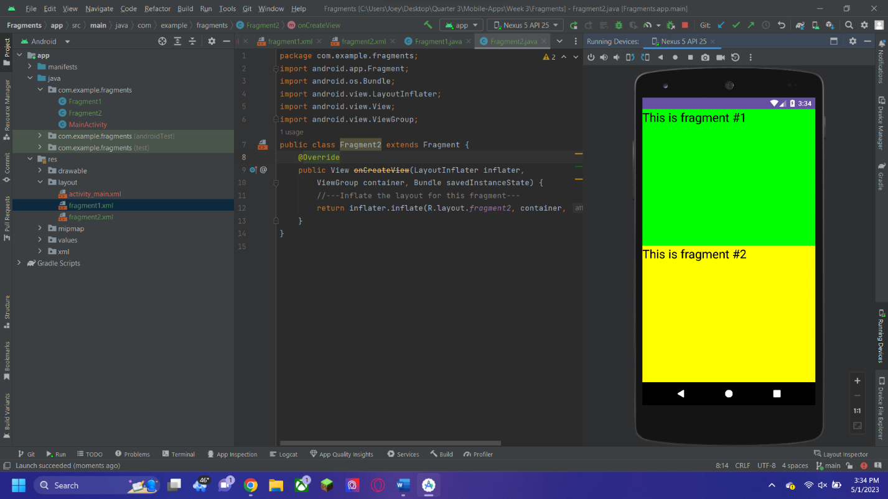

This is the result from the first assignment. After creating the project and the necessary files, I followed the instructions to add the necessary code and the result is easy to get from that.

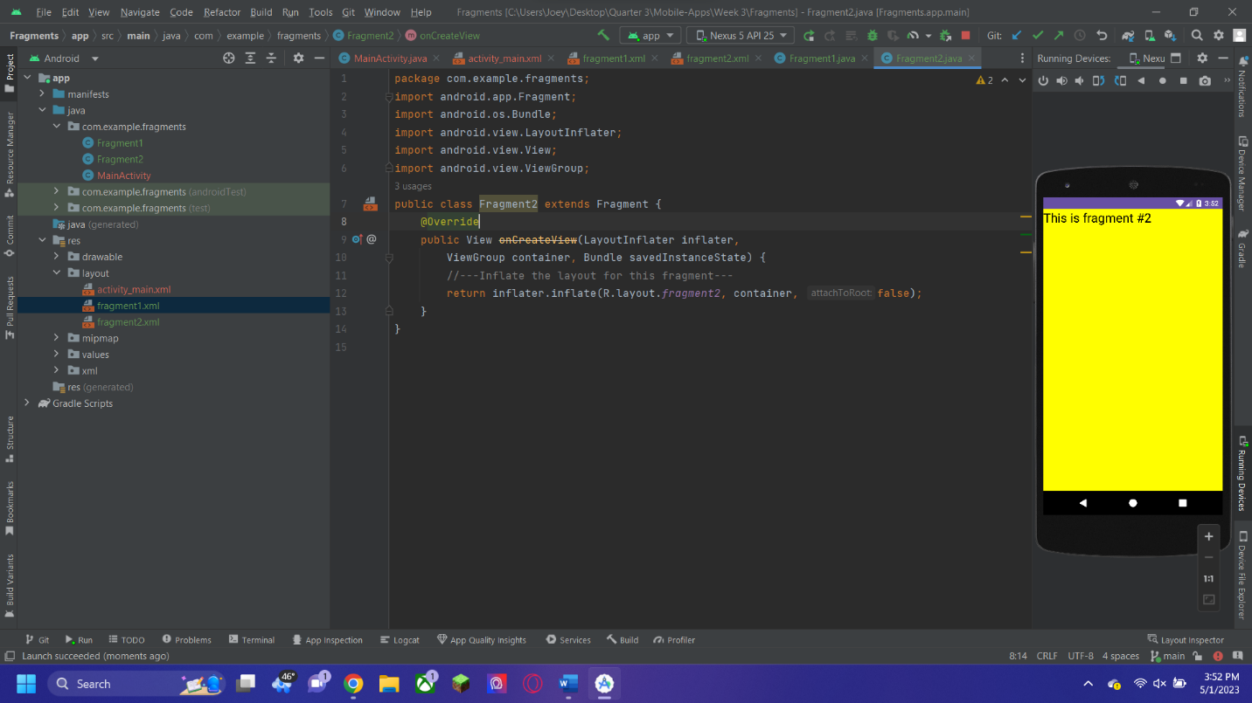

This is the result from the initial run of the second project, and to do it, I just copied the first project and only had to change the code in one of the files to get the needed result. 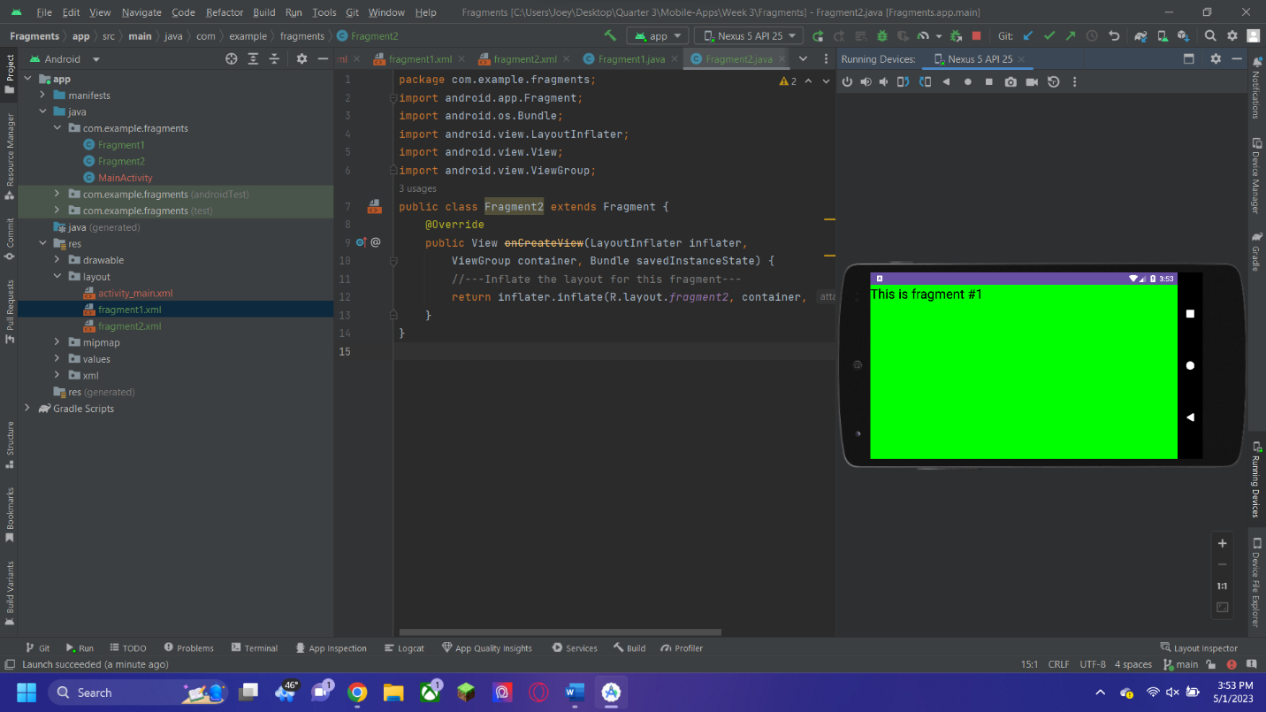

After rotating the screen to fit the phone to landscape mode, the output of the code changes and the results are different.

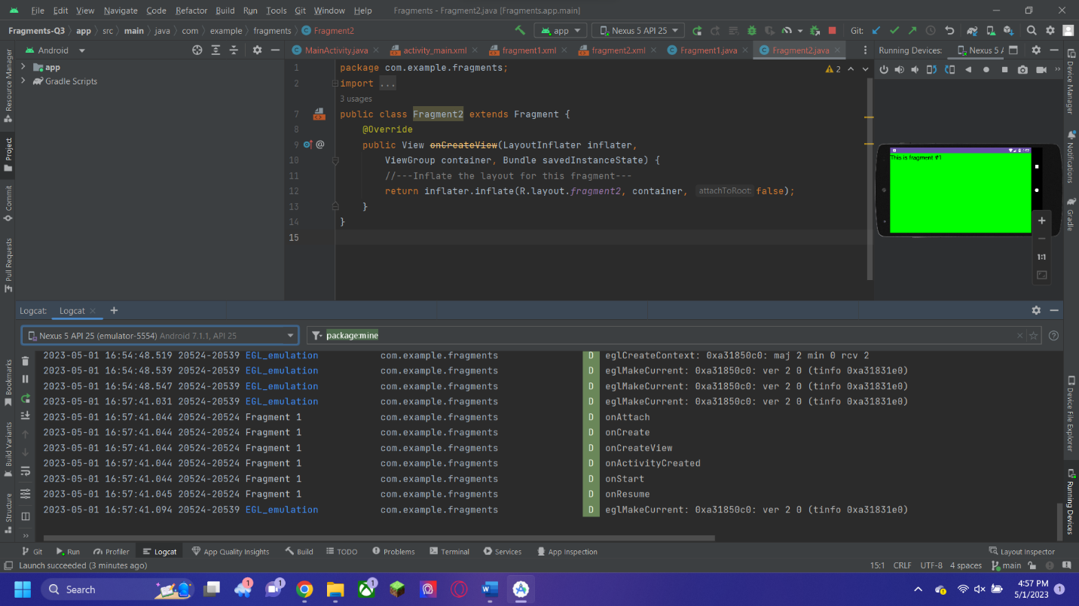

After creating the last project and again only needing to change a little bit of the code, I got the expected results to appear on the screen. The output shows the actions and lifecycle that the application went through in order to successfully run.

Here is the link to my GitHub repository for the class: <https://github.com/jball963/Mobile-Apps>

This assignment is in: Week 3/Assignment2_JosephBall